Name: Jackeline Figueroa​

Lesson 5: Joins and Unions

1. Join the film to the film_actor table.

Select *

From film_actor Inner join film on film.film_id = film_actor.film_id;

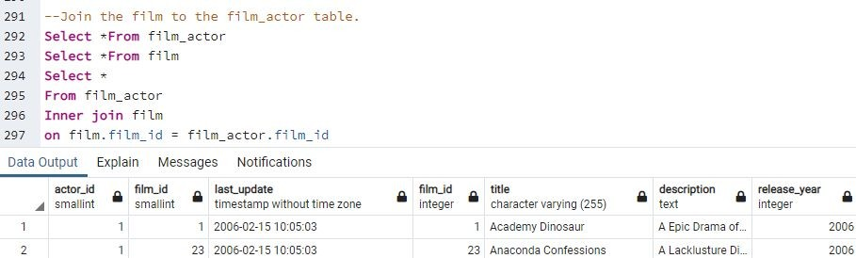

1. Join the actor table to the film_actor table.

--Opt# 1 includes all rows

Select*

From film_actor

Inner Join actor

On actor.actor_id = film_actor.actor_id; --Opt# 2 with selected rows

Select actor.actor_id, first_name, last_name

From film_actor

Inner Join actor

On actor.actor_id = film_actor.actor_id;

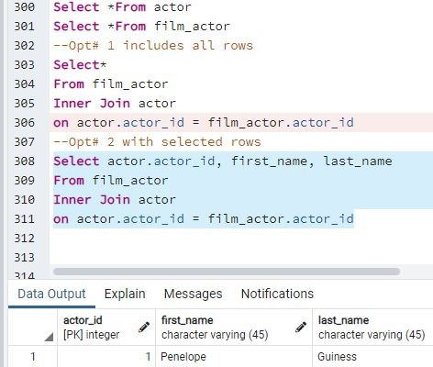

3. Try to join the actor, film_actor, and film table together (3 joins!)

Select actor.actor_id,first_name, last_name, film.film_id, title,description

From film_actor

Inner Join actor

On actor.actor_id = film_actor.actor_id Inner Join film on film.film_id = film_actor.film_id;

